- Research Question: Does a higher level of otaku culture popularity correlate with increased revenue from RPG mobile games in a country?

- Otaku culture originates in Japan and has spread globally with strong interests in Anime, Manga, and video games. This kind of subculture gains attractions in different countries. Anime-style role-playing mobile games (aka RPG) with the gacha mechanism have become frequent game revenue climbers. Companies that design the gacha-mechanisms provide a regular rotation of characters/weapons in the gacha pool. They induce popular and powerful characters to attract more and more players (potential consumers), and build an in-game payment channel for players to extract their desired characters. This game genre’s revenue has been soaring:
“MiHoYo struck gold with its iconic game Honkai Impact: Star Rail. On the day of its release, it topped the free charts in 114 regions and generated $20.6 million in revenue within 5 days of launch, with cumulative revenue reaching $112 million within 30 days.” (SocialPeta, 2023)
https://www.businessofapps.com/insights/marketing-trends-for-global-mobile-games/

As various industries, including mobile gaming, are likely to experience changes in revenue and user engagement. If we can understand whether there is a relationship between otaku culture and mobile game revenue, especially RPG type,and how, companies can develop marketing strategies with game designs and collaborations with other industries.

- Data source: https://www.data.ai/en/;
https://sensortower.com/;
https://animecons.com/events/
Above data source provides insight about mobile app (game) downloaded, some digital data needed, and the anime convention scheduling data.
Since this kind of market is emerging and no mature data collections from my searching so far, I try to collect all data from different reliable websites (like governmental releases/WorldBank) and institution reports and then build my csv file.

- Dependent variable: Revenue from RPG mobile games in each country.
Independent Variable: Otaku culture popularity index in each country
Other potential independent variables:
Anime/Manga Releases: A surge in popular releases can influence interest in related games.
Merchandise Sales: The revenue from otaku-related merchandise like figures, apparel, posters, etc., showing strong engagement with otaku culture.
Social Media Engagement: Metrics like mentions, hashtags, or trends related to otaku culture on platforms like Twitter, Instagram, TikTok, Youtube, etc.

As otaku culture is more popular among young people, the age of people.

- Mechanism: Since otaku culture becomes more popular globally, the exposure and acceptance of its associated aesthetics and narratives. A greater demand for RPG mobile games is coming because this genre of games is directly related to popular anime and manga, or included some similar elements. Also, otaku fans are zealous for deep engagement so they will promote these games more enthusiastically, which leads to higher user acquisition and in-game purchases. Most companies can, or have already, capitalize on this popularity by hosting offline events (anime/manga conventions) to further increase revenue.

Otaku culture, originating from Japan, refers to individuals with obsessive interests, particularly in anime and manga. This culture has undoubtedly had an impact on the mobile game market, especially in the realm of games that focus on anime and manga themes. The link between otaku culture and the mobile game market can be investigated from an econometric perspective by examining various facets.
- Demand Analysis:
  - Otaku individuals tend to be devoted consumers. A mobile game that appeals to otaku sensibilities, such as a game featuring popular anime characters or storylines, can draw in a dedicated base of users.
  - As a result, game developers have noticed the potential profit to be made from otaku-themed games, leading to an increase in supply.
- Cross-Marketing:
  - Otaku-themed mobile games often have cross-marketing with anime series, manga, and merchandise. This provides a synergistic effect: the anime/manga boosts the game's popularity, and vice versa.
  - Econometrically, one could model the cross-effects by observing the relationship between the release of new anime episodes and spikes in mobile game downloads or in-game purchases.
- Monetization Strategies:
  - Gacha mechanisms, which have roots in Japanese capsule-toy vending machines, are a popular monetization strategy in mobile games. These systems resemble gambling, where players spend in-game currency (often bought with real money) for a chance to get a rare character or item.
  - Otaku consumers, given their passion and dedication, might be more willing to spend money on these gacha pulls, especially if it involves a favorite character. Econometric models can be developed to investigate spending behavior in relation to the introduction of new, desirable characters.
- Cultural Export:
  - The global popularity of anime and manga has expanded otaku culture beyond Japan. This means that otaku-themed mobile games can have a global audience.
  - Econometric analysis can investigate the penetration of such games in non-Japanese markets and relate it to the growth of anime and manga popularity in those regions.
- Data Analysis:
  - Econometricians can utilize time-series data, looking at the introduction of otaku-themed mobile games over time and their subsequent success in the market. This can be compared with non-otaku-themed games.
  - Panel data or cross-sectional data can also be useful, examining different games, their themes, and their success metrics.
- Variables to Consider:
  - Dependent variables could include metrics like monthly active users, in-game purchases, and total downloads.
  - Independent variables could encompass otaku-centric themes (perhaps a binary variable indicating if a game is otaku-themed or not), introduction of new anime series, popularity metrics for related anime/manga, among others.
In conclusion, otaku culture has played a significant role in accelerating the mobile game market due to the symbiotic relationship between anime/manga and gaming. An econometric approach can quantify these relationships and provide insights into how game developers and marketers can best tap into this dedicated consumer base.

Article Presentations.
Adams, M. J. (2022). Tech Otakus Save the World? Gacha, Genshin Impact, and Cybernesis. British Journal of Chinese Studies, 12(2), 199–208. https://bjocs.site/index.php/bjocs/article/view/199 (Access the link or see pdf version)
Sections:
Skim Abstract and Methods and 4: Virtual reality, livestreaming, and idols on the Chinese periphery;
Read 5: The world as viewed from Genshin Impact;
Skip others

If interested, !!!not necessary:
Blake, S. (2023, July 25). Genshin Impact Revenue and Usage Statistics (2023). Mobile Marketing Reads. https://mobilemarketingreads.com/genshin-impact-revenue-and-usage-statistics-2020/
Fung, A. (2017). The Impact of the Rise of Mobile Games on the Creativity and Structure of the Games Industry in China. In D. Y. Jin (Ed.), Mobile Gaming in Asia: Politics, Culture and Emerging Technologies (pp. 91–103). Springer Netherlands. https://doi.org/10.1007/978-94-024-0826-3_6 (skim Abstract)
Hernández-Pérez, M. (2019, April 28). Arts | Free Full-Text | Looking into the “Anime Global Popular” and the “Manga Media”: Reflections on the Scholarship of a Transnational and Transmedia Industry. https://www.mdpi.com/2076-0752/8/2/57 (Skim 1.1. Anime and Academia)
Kam, T. H. (2013). The common sense that makes the ‘otaku’: Rules for consuming popular culture in contemporary Japan. Japan Forum, 25(2), 151–173. https://doi.org/10.1080/09555803.2012.743481 (Skim Abstract)

Relevance:
My research is focusing on the correlation between otaku culture and the ACG mobile game market (mainly about RPG games). This article provides a broad view/big picture of how otaku culture affects the mobile game market with a specific example, Genshin Impact, but it lacks statistical data. It mentions several factors affect why consumers purchase this kind of free-download games:
Gacha-Mechanism, Media Influence (Social media promotions), Character Attachment (design aesthetic), Regional Culture and Cultural Identity, Governmental Support.

Outline:
As the emerging mobile game market is developing to mature, its market share is increasing.
Since 2017, RPG mobile games have become the mobile game category with the highest user spending in the world for six consecutive years (Sensor Tower).
“Total revenue in the Role Playing Games market is projected to reach US$63.24bn in 2022 ”(statista). https://www.statista.com/outlook/dmo/app/games/role-playing-games/worldwide

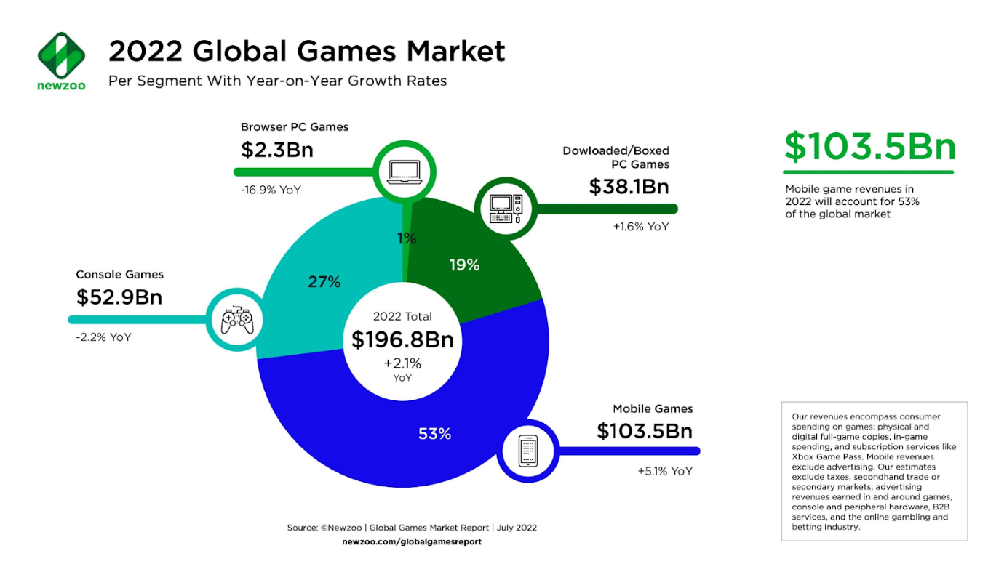
（Newzoo)
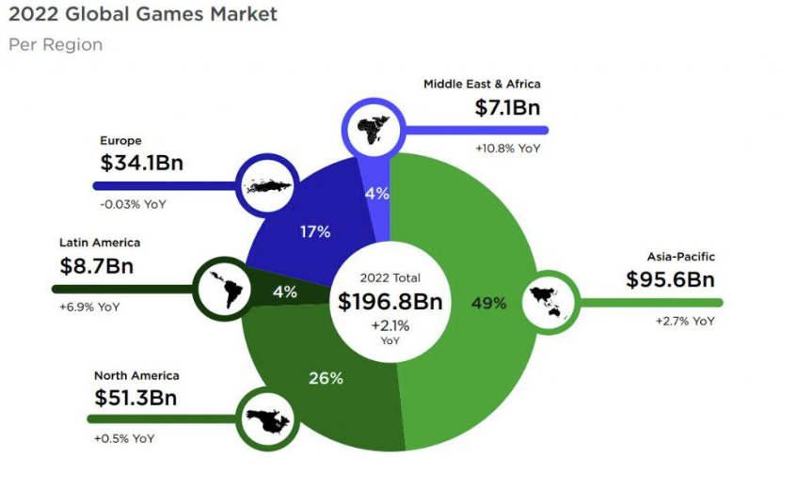
（Newzoo）

Data Tracking:
App data:
Data.ai; Sensor Tower; Newzoo; Statista;
Anime, Comics, Game - related publications:
Jstor; Scopus (Elsevier); Web of Science (Clarivate Analytics);
Social Media:
Youtube; Tiktok; Niconico; BiliBili; Twitter (X); Facebook;
Focused regions: Asia(Japan, China, Korea), North America(the U.S., the U.K), Europe.

Variables:
Dependent variable: ACG mobile game revenue (searching company financial reports).
Independent variable: Measure of otaku culture popularity (could be sales of related goods, attendance at conventions, etc.).
Control variables: Other factors that might affect ACG mobile game revenue, such as average income, smartphone penetration rate, internet accessibility, AI-technology (or V-tuber impact), monopoly problem, etc.

Econometric Model: Regression model.

Problems: Data constraints ( Game data is highly based on the Company report, concealment might happen, cultural nuances not captured, Impact of government released news, etc.), Lack of direct-correlated literatures

Importance:
Industry Growth and Strategic Development: Understand market needs and potential opportunities in different countries. Influence decisions related to localization and cultural adaptation.
Consumer Behavior Insights: Cultural influences on consumer behavior, preferences and consumption habits.
Media and Entertainment Trends: Metaverse, Social Media Hashtags (Promotions for related topics)
etc.

COMMENTS

Kevin | Do you think you can use proxies for anything that may be difficult to find data in. What origin location are you targeting? You need to do alot of explaining or examples of the games/topic you are looking into if you are going to use any examples for the uninformed audiences.
Anny | excused
Jack | I think one thing that is interesting that you talked about was looking at the specific events in each country rather than looking at the overall country consensus as your data points will be way more collective within the populations you want.
Lucy | You mentioned that the market is relatively new, I am curious how you’re going to find data that will bring validity to your research topic. Also do you know how you’re planning on obtaining the new data? And I wonder if there is a historical scenario that is similar enough to your current topic that would possibly have more available data if you aren’t able to find enough data for your proposed topic.
Noah | How does gambling play a part in this? I understand that you can have gotcha where you pay money but it's not necessarily considered gambling, but I also know many games have removed their loot box systems because it may not be accepted in some countries.
Nathan | I’m interested in how you will account for games that appear both in mobile markets as well as on consoles and more mainstream gaming devices. Games like Genshin Impact exist and are played in multiple markets. Will your data be using specific games, or a generalized market for mobile games.
Cooper | Maybe I'm looking too far into the future for your project but I still don't fully understand the kinds of variables you want to look into. I understand a high level causality which you are trying to look at but I still don't fully understand the specific variables you want to use as a proxy for these things. Also I'm curious about any comparisons which have been made to slot machine gambling?
Conner | My questions with “otaku culture” is how are you going to feel confident in the impact of specific indicators? It seems like there could be many potential factors to study that could have an impact on gacha culture. If these conventions are the primary indicator along with social media indicators, perhaps you could also include an indicator for general internet interest such as google search indicator. This could help to understand how often people are interested in the specific topics within the realm of “otaku culture”.
Chase | excused
Sam | Otaku culture is such an outspread system in the current year that it may be difficult to find data relating to the sales of “Otaku media” alongside the sales of these RPG games. What is going to be defined as Otaku media in this case, depending on how broad you go you could be looking at all sorts of data that can be hard to compile into one independent variable. The market sales for otaku related media would be arduous to find on its own, and using convention attendance would be more reliable to find but less consistent since not all otakus find their way to the conventions in the fist place. Perhaps you could narrow it down to the popularity of specific Otaku media as it correlates with particular Otaku RPGs or Gacha games? A lot of fixed effects would need to be controlled for, which can be tougher if this phenomenon is too recent. You could focus on the sales of one of the most popular forms of otaku media; shonen jump, and how it correlates with the sales of these newer games? What would such correlation imply, though?
Zerek | Having more data will help your thesis be stated clearer. The impact of the metaverse in America is nearly the same as the impact of Genshin Impact. So if you want to have more data I would try to find something similar to Genshin impact in the Metaverse and you'll have a better chance at finding more data.

